Powering the Glow: CIMCON Brings Smart Control to India's Longest Sea Bridge
India's longest sea bridge is making headlines, and behind the marvel is a smart-lighting story worth telling.

India has built something the whole world has taken notice of, and at CIMCON, we are proud to be part of it.
The Atal Setu, officially the Shri Atal Bihari Vajpayee Trans Harbour Link and widely known as the Mumbai Trans Harbour Link (MTHL), stretches an incredible 21.8 kilometers across the open sea between Mumbai and Navi Mumbai. It is India's longest sea bridge, ranks among the longest sea bridges in the world, and has dramatically cut the travel time between the two cities. More than a feat of engineering, it has quickly become a symbol of a modern, fast-moving India.
The headlines rightly celebrate the scale, the ambition, and the sheer speed of it all. But every great piece of infrastructure depends on something quieter working flawlessly in the background. For a bridge like this, one of those things is light. And we are honored that our smart lighting technology helps keep the Atal Setu glowing, every single night.
Curious how the same smart control could work for your city or project? Talk to our team →

India's longest sea bridge, managed by CIMCON's smart lighting control.
‘”

A bridge this big never sleeps
To understand why smart control matters so much here, it helps to picture what a bridge of this size demands once the sun goes down.
Every night, thousands of light points must switch on and stay across more than 21 kilometres of open water. And they must do it in one of the harshest environments for electrical infrastructure found anywhere, with constant salt in the air, strong coastal winds, high humidity, and a relentless stream of high-speed traffic that never stops.
On an ordinary city street, a single failed light is a minor inconvenience. On a high-speed sea bridge, it is a genuine safety concern. Drivers depend on consistent, even illumination to judge distance and stay safe at speed, so a dark stretch is simply not acceptable, not even for a night.
And here is the part that makes it truly challenging. You cannot simply send someone to walk along the bridge and inspect each light. Across 21.8 kilometres over the sea, manually checking thousands of fixtures, spotting failures, and tracking energy use would be slow, expensive, and in many places impractical. Keeping a bridge like this reliably lit is not a job for more people on the ground. It is a job for smarter technology.

Smart control, from one screen
At the heart of the Atal Setu's lighting is CIMCON's Centralized Control and Monitoring System (CCMS), the intelligent system that brings the entire network together under one roof.
In simple terms, a CCMS connects every light on the bridge back to a single control screen. From that one place, the full 21.8 kilometres can be seen and managed in real time. Rather than placing fragile equipment on every pole, CIMCON's approach puts intelligence at the feeder level, where one smart controller manages a whole group of lights at once. That means fewer points of failure, lower cost, and one clear, unified view of the entire bridge.
The lights stay connected through a robust communication network, so information flows constantly between the bridge and the control room. The instant a fault appears anywhere on the span; the system flags it immediately, allowing the team to respond quickly, very often before anyone travelling across the bridge would ever notice that something was wrong.
This is what intelligent lighting control delivers:
- Live visibility of every light across the entire bridge, at any moment
- Instant fault alerts, so issues are known the second they happen, not after a complaint
- Remote control of the network, managing the whole span without a single site visit
- Smart energy management, using power only where and when it is genuinely needed
► Watch: See the Atal Setu Come Alive
CIMCON's smart lighting control in action on India's longest sea bridge.
Each of these capabilities solves a real, practical problem. Live visibility replaces guesswork with certainty. Instant alerts turn what used to be days of delay into a matter of minutes. Remote control removes the need for constant trips onto the bridge, which is invaluable where access is difficult, and conditions are tough. And smart energy management makes sure the bridge draws only the power it truly needs, night after night, across every kilometre.
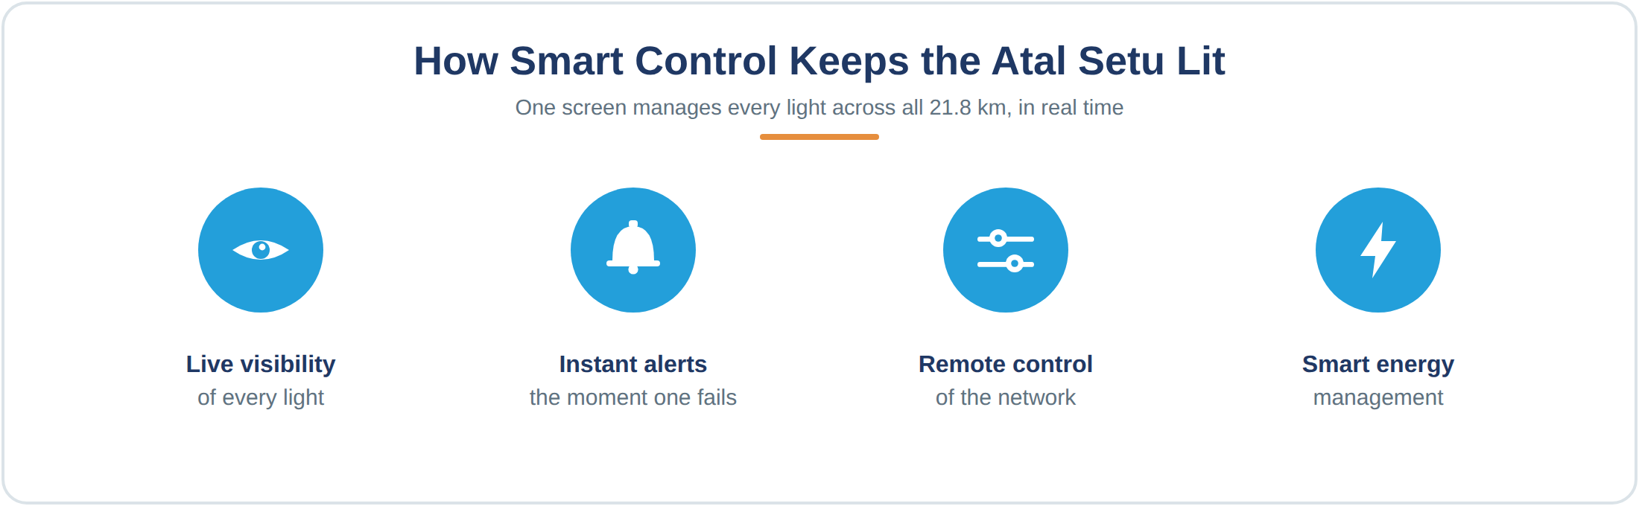
Four things a CCMS does across all 21.8 km of the bridge, from one screen.

Brilliant results, at the toughest scale
Managing lighting across an open-sea bridge is about as demanding as street lighting ever gets. Which is exactly what making the results so remarkable:
- 40% reduction in energy use
- 40% savings in cost
- 99% uptime across the length of the bridge
A 40% reduction in energy use is significant anywhere, but across a network this large it means major savings and a meaningfully smaller carbon footprint. A 40% saving in cost frees up valuable public resources that can be put to work elsewhere. And 99% uptime means the bridge stays reliably lit almost without interruption, which on a structure like this is a direct contribution to the safety of everyone who crosses it.
Crucially, these are not figuring from a controlled laboratory test. They come from a living national landmark, performing night after night in the open sea. That is the real measure of what intelligent control can achieve.
You can see more real-world results in our smart lighting case studies.

What this means for cities, highways, and authorities
Here is the genuinely exciting part, and it reaches far beyond this one bridge.
If intelligent control can run 21.8 kilometres of critical sea bridge flawlessly, in the toughest conditions imaginable, it can comfortably transform how any city, highway, or industrial corridor manages its lighting. Most networks are far smaller and far less demanding than a sea bridge, which means the same technology is more than capable of handling them with ease.
For a municipality, that translates into lower energy bills, reduced maintenance costs, faster fault resolution, and fewer citizen complaints. For highway authorities, it means safer roads and dependable illumination across long, remote stretches. And for everyone involved, it means a lighting network that can finally be seen, measured, and managed, rather than simply switched on and hoped for.
In most cases, the infrastructure is already in place. The lights are already there. What transforms them from a running cost into a smart, controllable asset is the layer of intelligence added on top, which is exactly what a CCMS provides.

Smart lighting: the first step to a smarter city
There is a bigger picture here too. Once a lighting network is connected and intelligent, it becomes the foundation for much more.
The same connected backbone that manages streetlights can, over time, support other smart-city services and connected infrastructure. This is why smart lighting is so often the first practical step a city takes on its journey to becoming truly smart. It delivers immediate savings and safety benefits, while quietly laying the groundwork for everything that follows.
The Atal Setu is a powerful example of that shift in action: lighting that is no longer simply switched on and off, but truly seen, controlled, and managed. It is living proof that technology works, at scale, in the toughest conditions, right now.

A proven partner in intelligent infrastructure
CIMCON has been at the forefront of intelligent outdoor infrastructure for over 35 years. Our smart control systems help light and manage networks across 150+ cities in more than 24 countries, with over 1,200,000 controllers deployed worldwide, helping create safer, better-lit streets for more than 2.79 million people.
From national landmarks like the Atal Setu to city roads and highways across the country, our focus stays the same: giving the people who manage public lighting complete visibility and control, while cutting energy use, lowering costs, and improving safety. Proudly Made in India, our solutions are built for the scale, and the real-world conditions, that infrastructure like this demand.

Illuminating the road ahead
At CIMCON, we do not just help with light roads. We help light the future of India's cities.
Being part of the Atal Setu is a proud milestone, and a glimpse of what intelligent infrastructure makes possible. From sea bridges to city streets, we remain committed to smarter, more sustainable, and more reliable lighting for communities everywhere.

Bring the same smart control to your network
If a CCMS can run India's longest sea bridge, it can transform how your city, highway, or project manages its lighting. Let's talk about what it could do for you.
➜ Explore CIMCON Smart Lighting
➜ Talk to our team

CIMCON is a leader in intelligent street light control and smart city technology, with deployments across 150+ cities in 24 countries. Our Centralized Control and Monitoring Systems help cities and authorities cut energy use, reduce maintenance, and keep their streets reliably lit.

